THESE CHAIRS ARE NOT FROM AN ICE CREAM PARLOR.

They sat in a gas station for 44 years, the Table Rock Oil Company station, and a lot of sitting has been done on them. This is the history of that station.

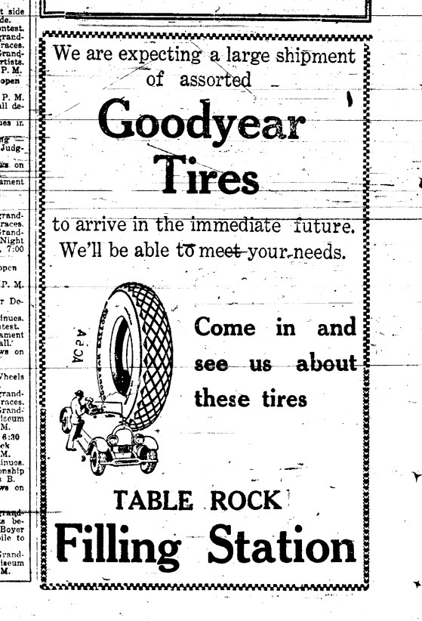
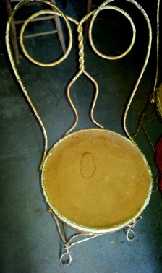
In 1926, an auto mechanic and a barber opened the first service station in Table Rock. Paul Diehm and Wes Bailey were Johnson men. They located between what are now the buildings of Binder Brothers and Dentist Billy Bob Laun. They furnished it with a table and four of these chairs.

Table Rock then had about 700 people. It eventually was a Phillips 66 station, but in the early years, there was only one station, and it was simply the Table Rock Filling Station, as in this 1927 ad from the Table Rock Argus, to the right.

In 1927, Paul and Wes put in a bulk tank plant to provide service to the County. The tanks were near the switch track in the south part of town, on land that they bought from Dr. McCrea. Fuel was shipped in on the Burlington Railroad for many years; eventually it was trucked in. In 1936, Wes died and Paul became sole proprietor.

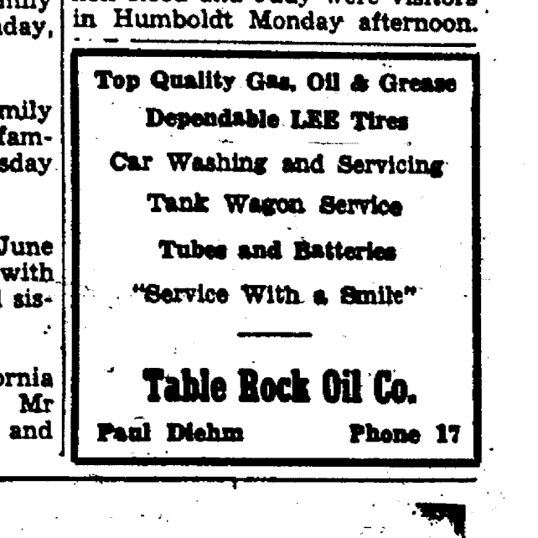
At some point, the business became known as Table Rock Oil Company, as in this 1948 ad from the Argus on the left. Note the phone number: 17.

In 1958, Paul broke his ankle and, after 32 years in the business, decided to bow out. He was 68 at the time. He leased the station to Wayne, who had worked for Paul before a stint in the Army Air Corps and who, after working in Wyoming for a while after his military time, returned in 1950. Wayne continued as proprietor of the station until it was sold. which was believed to have been in about 1970.

In 1964, a tank truck caught fire as Wayne was loading it, and the truck and pump house were destroyed; the fire badly damaged the bulk plant. Wayne relocated it to land west of the depot that he bought from Mrs. Frances Norris.
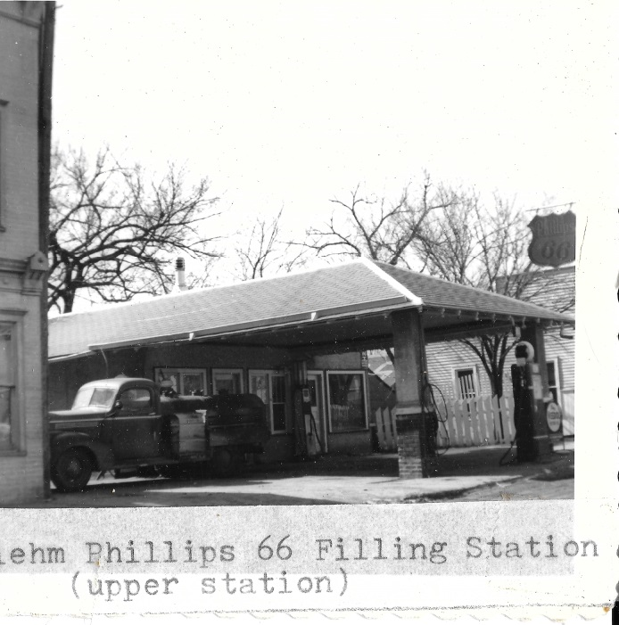
Paul died in 1975 at the age of 85, and is buried in the Table Rock Cemetery, as is his wife Pearl, who died in 1979. By that time, Table Rock had only about 400 people. Wayne died in 1992 at the age of 67; by that time Table Rock had only about 300 people.

The station – to the left circa 1966 -- gave jobs to many men over the years. Carpenters Harry Freeman, Bill Linn, Charlie Linn, and William Jennings built the station in 1926. While Paul operated the station, Paul’s sons Wayne and Harold, as well as Rudy and Andy Zelenka, and Bill Knippelmeyer worked there. Jim Jobe was the tank driver for several years at the beginning of the business. After Wayne took over the station, his son John, as well as Rudy Fritch, Larry Aylor, and Don Mertes worked there.

