Photo notes for 1 to 100

Photo 8. Facebook posting, July 2015.
Stan Sitzman: If you look to the left, you see what appear to be bricks... Perhaps this is the 'vehicle' bridge to the brick factory with the RR bridge beyond it...?
Those appear to be wood sheathed Burlington Route box cars with the roof walks intact so it's pre-1960s. Definitely NOT the bridge over the RR... The RR runs parallel to it not under it.

Photo 13, cast of a Womanless Wedding, Photos 13B and 13C for the casting. Cast members identified with the photo: Albert Wopata, Clay Cook, Ludwick Janas, Charles Barker, L. Trout, C.J. Wood, Ed Dorland, Gus Metger, Aubra Duncan, Professor Wilson, C. I, Norris, John Tomek, Wayne Kubic, Jim Jobes, Bill Vondrasek, Hollis Burrow, Will Alderman, Lynn Snell, _____ Petrashek, A. Petrasek, P. J. Hnizda, Hugh Hodell, Harold Martin, Guy Bonham, Art Horton, Ernest Kaiser, Frank Tomek, Ralph Cotton, Joe Tonek, S.V. Bailey, Leser Taylor, EdTomek, Jesse Wopata, H. ____Hugh? Cage?, Dr. Kuhlman, ______ Colling, James _____ Mahon?, Ed Hanna, Roy Shepherd, Edwin Hinds, Frank Kovanda, G. Wood, Jess ?, h.l. _____ Kenner, Lewis Hubka, Col. Dow, Art Linn, R. ____?, CharlieJones, E.J. Norris, john Groff, Will Linn, Gordon Bethel, Don ____ Pugh?, Edwin Freeman, ______ Zink, Orville Jones, Louis _____, Archer Harris, Lawrence Duder, Lavon Jones , ____ Ritchie, Albrt Stanek, Byron Catt_____, __________, ______________, Rudolph Zelenka, Irwin Morton.
Photo 20, Czech band, bohemian band, in front of Motor-Drome. Back row: Fred Tomek, Rudolf Kroft, Rudolf Kalina, Art Krofta, Charlie Rabstejnek, Ralph Cotton, and Otto Vondrasek. Front row: Joseph Tomek, Arnold Petrasek, Emil Rabstejek Arnold Petrasek, Benny Irwin, and Chester Fisher

.
Photo 23. High school 1921-22, labeled as “Class of 1921-22” but being perhaps the entire high school given the number of students.
On the far left of the 2nd and 3rd rows are Marvin Shepherd and Ruby Shepherd. Ted Quackenbush’s wife is a Shepherd descendent and confirms that they are Ruby Shepherd McAlpine and her brother Marvin, November 2014.
On the 8th from the left in the front row is Willis Bethel. Kathy Bethel Johnson-Wee Kait says that Willis was Gordon Bethel’s brother: “My Uncle Will! He was the little brother, and was very much the little brother! I loved my Uncle Will!” In another post, she noted “My Matt has the same look.”
Front row: Edwin Swartz, Willie Slack, Hobart Phillips, Durward Hayek, Frank Langr, ARt Graham, Homer Johnson, Willis Bethel, Lavon Jones, Ed Blecha, Cecil Horton, Leonard Reuter, Hollis Burow, Rudolph Zelenka, Ray Aylor, Lawrence Duder. Second row: arvin Shepherd, Anthony Zelenka, Frank Briant, Lee Cross, Raymond Babcock, Lloyd Covault, Ludvig Jasa, Jess Wopata, George Tibbets, Frederick Wood, Grace Bedea, Della Bowen, Eunice Schasse, Emma Bily, Stella Bowen, Emma Wood, Mildred Griffig, Supt. E. D. Trump. Third row: Ruby Shepherd, Eileen Shelenbarger, Edit Petitt, Nellie McKnight, Ellen McKnight, Io Gates, Mabel Hansen, Ruth HOrton, Mary Wood, Emily Stech, Cleo Aylor, Helen Bain, Tony Tlustos, Emma Vrtiska, Jane Tenk, Lou Smith, Jennie Langr, Mildred Kent, Emma Fritz, Jessie Hanna, Marjorie Phillips, Lona Jones, Mildred Brock, Laura Aylor, Ural [sic? – Uarda?] Freeman, Gladys Herrick, Otilie Kotalik, Ruby Petitt, Mildred Nickelson.

Photo 27. Kathy Johnson Wee-Kait posted this on 12/11/14: My grandpa, Gordon Bethel, purchased the Madden Drugstore in Table Rock from Ines E. Madden (a widow) on March 13, 1961 for $4,000.00. He renamed it "Bethel Drugstore" and sold it on April 19, 1971 to Abe and Judy Lutfiya for $3,000.00.

Photo 28. Class of 1960. Back row far left is Dennis Bernadt, identified by his sister Cat. Front row third from left is Marlene Kolacney Warnick. When posted on Facebook asking for the other names, Jackie Uhri said: I believe third from left is Marlene Beranek. Front row---Larry Covault, Carolyn Jasa, Marlene, Carol Badberg, ??, Gary Herrick. Back row, Dennis Bernadt, Leland Michal, Joe Smith?, Gary Aylor, Don Wright, Wayne Klein. Marge Hunzeker said: Back row from left: Dennis Bernadt, Leland Mitchell(sp?), Joe Smith(?), Gary Aylor, Don Wright, not sure on last one. Front row from left: Larry Covault, Carolyn Jasa, Marlene Branek, Carol Sue Badberg, ? is that Joyce Marfice, Gary Herrick..
Deb Aylor gave the most certain and complete listing:
- Left to Right Front Row: Larry Covault, Carolyn Jasa, Marlene Branek, Carol Sue Badberg, Joyce Marfice, Gary Herrick; Left to Right Back Row: Dennis Bernadt, Leland Michal, Joe Smith, Gary Aylor, Don Wright, Wayne Klein. Gary Aylor says that Bob Freeman is missing.

Photo 38, baseball team. Standing: Robert Wiar, Orvin Gold, Vern Talbot, Jay Johnson, and Gerald Wood. Seatged: Clyde Talbot, Max Glenn, Edwin Freeman, Lester Taylor, and Virgil Frank.
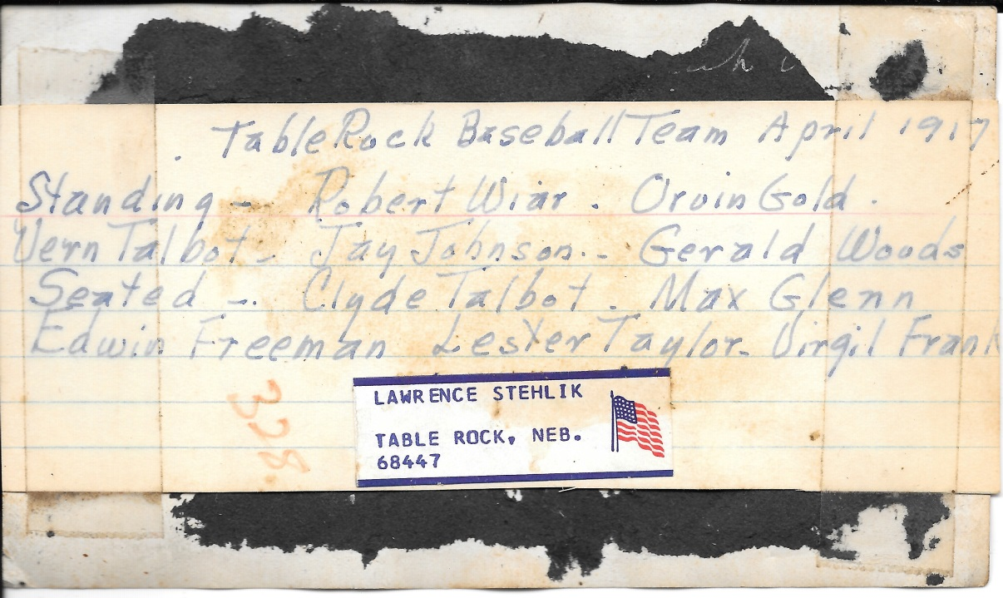
Photo 40, 1909 boys basketball team. On back is written Floyd Poteet, Supt., W.H. Simons, and, starting with the upper row: Glenn Wood, Hubert Voller , Earl Irwin, Eugene Woods, Raymond Andrew

Photo 44. 1915 Table Rock Band. Back row: Fred Tomek, Tom Krofta, Rudolf Kalina, Art Krofta, Charles Rabstejnek, Ralph Cotton, and Otto Vondrasek. Front row: Joe Tomek, Frank Tomek, Jess Vondrasek, Emil Rabstejnek, Arnold Petrasek, Earl Irwin, and Chester Fisher

Photo 46, Class of 1911. Bottom row: Addie Wier Wilcox, Lillian Strejc, Ada Mort Tillman. Back row: Gertrude Glenn Trump, _____ Jobe Hazel, Hazel Taylor Kuhn, Callie Barrett, and Ella Beck Smith.

Argus 48. According to an attached label: “Table Rock Czech Band. Back: Rudolph Krofta, Charlie Rabstejnek, Arnold Petrasek. Front row: Art Krofta, Jess Vondrasek, Emil Rabstejnek, and Joe Tomek.
Argus 49: The labeling is vague. it names six men, but there are more than that in the group.
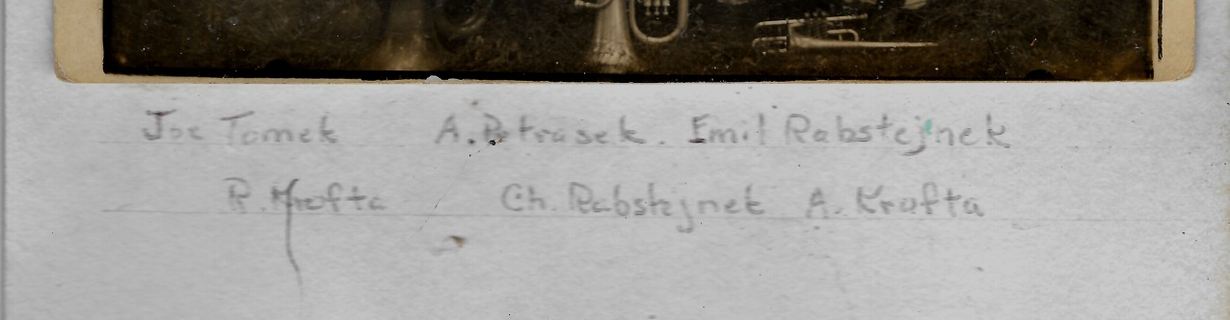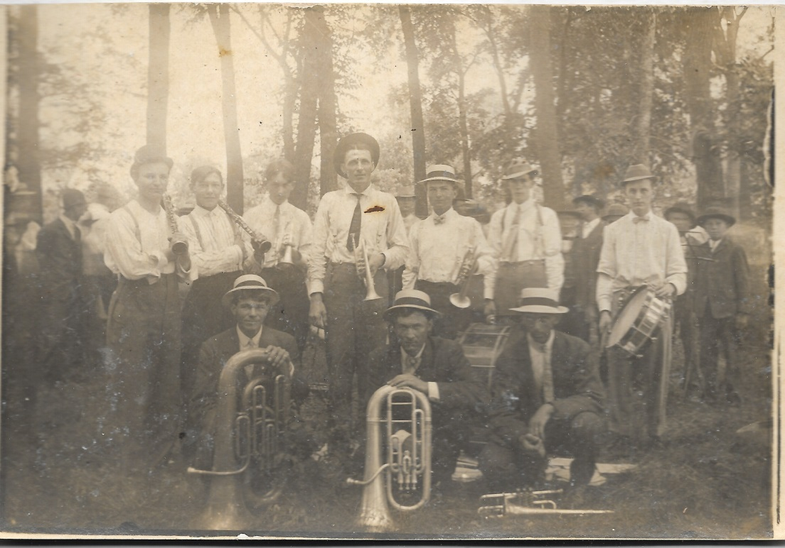
I asked (Table Rock) Bob Blecha for help. The clarinet player, first man on the left in a white shirt, is Joe Tomek. The tall trumpet player in the middle is Arnold Petrasek. The three men kneeling are Rudy Krofta, Charlie Rabstejnek, and Art Krofta. I recognize Emil Rabstejnek fromother pictures; he is to the right of Arnold Petrasek (on Arnold Petrasek’s left).

Photo notes for 51 to 75
Photo 52. 1905 8th grade graduation. Back row: Neil Dow, Nelle Schreck, Mabel Barnes, Prof. Simons, Teacher Maggie Engberry, Nelle Robertson, Winnie Broyles, and Ralph Stover. Middle row: May Mort, Eugene Wood, Mattie Bennington, Floyd Poteet, and Jennie Porter. Front row: Ella Snyder and Eunice Norris.
Photo 53. Front row: Workman, Joey ______, Bobbie Burgert, Jim Petrashek, Robert Workman, Greg Kreifel, Barry Fritch, and Scott Hanna. 2nd row: Nancy Workman, Sherry Sitzman, Anita Penkava, Karla Kalina, Patty Wenzbauer, Jean Michael or Michel, Marlys Binder, Bobette Vondrasek, Lori Petrashek, and Susie Marfice. 3rd row: Mary Bernadt, Rick Rabstejnek, Steven Binder, Allen Fritch, Kenneth Cumro, Gregg Clement, David __________, Tim Snook, and Antonette Kent. 4th row: teacher Elsie Wenzbauer, Becky Binder, Allen Gottula, Howard Frank, Eddie Findlay, Bradley Bowen, Danny Burger, and Ann Hanna
Photo 54. Class of 1955. Lee Rottman, Supt. Gordon Olson, June Senft; Isabel Marfice, Lucy Johnson, Jerry Rice, Wilbur Frederick, Garry Harris, Dorothy Reuter, Keith Johnson, Doris Williams
Photo 55. An All-Star Wedding, a 1952 community play. The producers/director of this production traveled from town to town, putting together performances with the local talent. Advertisers: Table Rock Electric, Karas Garage, Hutt Motor Company (Elk Creek), Table Rock Argus, Schroeder Cash Store, Fisher’s Tavern, Du-Bst Grocery, Home Oil Company, Paul Diehm Gas, Madden’s Store, Charles Harlow, State Bank of Table Rock, Reno Inn, Reeds Service, Howell Hotel, Steiner Machine & Repair, Humboldt Bottling Works, Cooper Seed Co. (Humboldt), A & E Bar, Farmer’s Co-Op, Kovanda-Beethe Funeral Home, Herr’s Dairy (Humboldt), and Stalder Brothers (Humboldt). Table Rock Community Club sponsored it. The actors: William Vondrasek, Nettie Stehlik, ARthur Meier, Willard Hanna, Marvin Kalina, Lawrence Stehlik, Howard Workman, Alfred Penkava, Elmer Gilbert, Orville McKnight, Delmar McClarnen, Albert Rexroth, Lawrence Wenzbauer, Lee Lang, Richard Karas, Allen Gold, M. C. Bonham, Ed Tomek, Ronald Workman, Frank Sochor, Edward Tomek, Wayne Minchow, Eddie Kent, Dale Johnson, Edgar Gilbert, Edmund Steiner, George Gilbert, Howard Howell, Lloyd Wright, Dale Wright Rudy Senft, Steve Stastney, Robert Laun, Roy Briant, Louis Sochor, Elmer Penkava, Lyle Hunzeker, Robert Vondrasek, Wayne Diehm, Vernon Reed, and Harvey Seider.
Photo 56 is a duplicate of Photo 55.
Photo 57, 1913 school play, Engaged by Wednesday (same photo is also identified as Married by Wednesday). There are two of the same photo with the name of the play in the picture; in one the play is called Engaged by Wednesday and the other it is called Married by Wednesday. There are THREE lists of names, even though the pictures are duplicates. THE LIST IN PHOTO 58 APPEARS TO BE THE CORRECT AND COMPLETE LIST OF NAMES. Two other labels are incomplete. One says that seated on top is Charlie Woods, left 2nd row is Lowrain McCrea, then Tillie Stanek, ______ and Hattie Binder. Left 4th is Raymond Andrew (German lady) , Raymond Glenn. 4th from right Lloyd Andrew. Seated on left is Elsie Shorter Miller (illegible), seated on right is Martha Branek. The other incomplete label says that in straw hats -- left of picture is Raymond Andrew and right of picture is Lloyd Andrew. Left 2nd row (white shirt) is Lowrain McCrea (mis-spelled Loraine); ______ hat is Charles Wood.
Photo 58 appears to be a correct and complete list of names for the 1913 play in Photos 56 and 57. Seated, Elsie Shorter, Bessie Wopata Farrar, Nettie Kovanda Beethe, Martha Branek Rice. Standing: Lowrain McCrea, Tilllie Stejc Stanek, Lena Branek Shepardson, Hattie Binder, Raymond Andrew, Mabel Murphy, Eva Irwin, Joy Talbot Stover, Lloyd Andrew, Verta Brock Wosmund, Ada Talbot Shilmachie, Hollie Bicknell, and Hal Wimberly. Up high, Charles Sutton Wood.

Photo 67. 1970-71 basketball team. Back row: Richard Burgert, Pat Workman, Ed Kroll, John Petrashek, Jim Goodenkauf, and coach Dave Oman. Fron row: Arlen Parde, Marty Conradt, Don Smit, Tom Mullins, and Steve Cumro.
Photo 68, Argus, 1963-4, 2nd & 3rd grades. Most of the students are identified on the photo. Top row: Randy Fritch, Sandy Sitzman, Antonette Kent, _________, Johnny Richardson, and teacher Elsie Wenzbauer. 2nd row: Danny Burger, __________-, _________, Steve Binder. 3rd row: ___________, Pat Workman, Allen Fritch, Greg Kreifel, Winfield McClintock, Gregg Clement. 4th row: Jeannie Mitchel, David Burger, Charles Rabstejnek, and Mary Bernadt. Bottom row: Kenny Cumro, Marilyn Church, Randy Rabstejnek, and Jon Binder.
Photo 69. Kindergarten and first grade for school year 1963-64. Top row: Patty Bernadt, Pam Tomek, Barry Fritch, Sherry gold, Chris Tomek, Bobbie Sue Stillinger, and __________. 2nd row: Laurie Petrashek, Brad Bowen, Donnie Kalina, and __________. 3rd row: __________, Karla Kalina, Bobbie Burgert, Brad Gottula, Ronnie Kalina. 4th row: Tom Workman, Howard Frank, Ed Findlay, Scott Hanna, Kay Wenzbauer, Bobette Vondrasek. 5th row: Nancy Workman, Anita Penkava, __________, and Marlys Binder. Bottom row: Sherry Sitzman, Susie Marfice, Becky Binder, Patty Wenzbauer, and __________Workman.
Photo 71. Bryan Goodenkauf, Rodney Covault, Linda Vondrasek, Shad Gager, Mike Workman, Steve Krikava, Ken Burgert, Terry Kalina, and Anita Jasa.

Photo 80, Class of 1913. 1 - Lena Berenek, 2-Ada Talbot, 3-Tillie Strejc, 4. unidentified, 5. Hattie Binder, 6. Joy Talbot, 7. Charles Wood, 8. Martha Beranek, 9. unidentified, 10. Bess Wopata, 11. Elsie Shorter, 12. Raymond Andrew, 13. Nettie Kovanda, 14. Eva Irwin, 15. Mabel Murphy.

Photo 81. Class of 1935. Top row: Fred Muscheites Dwight Bonham, Charles Hastings, Joseph Tomek. 2nd row: Bernice Barnard, L. Charles Harlow, Velma McCourtney, Russell Jones. 3rd row: Professor H. G. Patterson, Marion Bonham, Zethel Phillips. 4th row: Grace Mary Hunzeker, Philip Rabstejnek, Bernice Johnson, Harold Craig; 5th row: Edwin Fritch, Harold Kubick, Edward Miller, and Howard Bedea.

Photo 82 – Class of 1918: Top row: Julia Blaha Cacek, Robert Wiar, Albina Sedlak. Middle row: Jess Kovanda, Antonette Colling Kent, Max Glen, Dorothy Phillips Wilson, Vern Talbot. Front row: Harlan Taylor, Glen Kent, Mildred Herrik Mehlin, and Orvin Gold.

Photo 83 50th anniversary of Mr and Mrs Diamond/Dimon, a pioneer family. pioneer family. The people: ___ Stewart, ____ Phillips, Arthur Scism, Hazel Taylor, Mr. Dimon, Anna Dimon, Mrs. Dimon, Frances Hales, Anna Wilson, Harland Taylor, Mrs. McCaslin (Laura Covert is added in a note), 2nd row, M. H. Marble, Mrs. Richardson, Nettie Wilcox, Mrs. W. H. Wilson, Lydia Holmes, Mrs. Sam Wright, Uncle Ball (Benny), Auntie Ball, Della Griffing, Mrs. James Talbot, James Talbot, Taylor, Mrs. Frank Taylor; 3rd row, Mrs. M. H. Marble, Clara Scism, Mrs. Stewart, Mrs. C. I. Norris and Mr. C. H. Norris, Mrs. Fannie C. Norris, Mrs. J. W. Shaw, Mrs. W. A. Conklin, Mrs. O. W. Griffing, Mrs. Rice Martin, Rev. ____ Shamel, O. W. Griffing.
Photo 97, Mrs. Tom (Minnie) Kubicek

Photo 98, Julia Zelenka Petrashek (Mrs. John Petrashek), mother of Mary Petrashek Wopata and Frank Petrashek, Sr.

