PHOTO NOTES, PHOTOS 201 – 300
updated 8/20/15

Photo 201. Vet Wm. Frank in photo labeled as him with horse Viola Roberts. I posted it on Facebook on 10/17/14. Comments included, “It seems like the old timers talked about the horse races. All the fairs had races and were some ‘tracks’ just out in the country where friendly competitions were held.” That looks like a racing saddle, and the horse looks like a racehorse! Was there a racetrack around Table Rock?” Yes, indeed, the Table Rock Driving Park, built in 1882 according to the Argus in 1882. I don’t know when it ceased operations. Bill Frank, 1860 – 1941, http://www.findagrave.com/cgi-bin/fg.cgi?page=gr&GSln=frank&GSfn=william&GSbyrel=all&GSdyrel=all&GSst=31&GScntry=4&GSob=n&GRid=55244000&df=all&.
Photo 202, west of the square with the bank ithe main focus. On 1/4/15, I posted zoomed-in excerpts with these comments: “Photo 202 focuses on the State Bank of Table Rock, built in 1892. Take a closer look by zooming in with these numerous excerpts. You will see the Opera House built in 1893. But the building in which the Legion Hall is now located, which I'm pretty sure was also built in 1893, is not there yet! So this photo is probably circa 1893. That vague group of men in front of the bank is not so vague when zooming in. That's a pretty nice bicycle. The front doors of the bank were wood. The drug store was accessed via a wooden step. The stairs to the Opera House were not enclosed. Pope's store had very tall doors and a sign over it about Gilt Edge -- a saloon? There's a big hole and post by the man on the south side of the bank, what the heck? Oh yeah, and a dirt street.”
As to the view of the side of the building to the north of the Opera House, Kim Vrtiska looked more closely at the signs posted there and noted that this:. “Wait for Nevada in Opera House,” says one sign. “At the bottom, it says rain or shine. I would guess the large one behind it says Greatest Show on Earth.”
I checked the few editions of the Argus from 1893 and 1894 and found nothing about those show. although the ads are text and buried amongst socials and I did not look closely, just didn’t see anything when scanning. Kim then reported that he had checked the long historical article about the Opera House, which lists many productions, and didn’t find them, either. . http://www.nebraskahistory.org/.../full-text/NH1977Opera.pdf
Luella Hinrichsen commented, “Looks like Jed Clampet, back left side! ;) James Chauza,Sr. , Frank * Anton Bily lived there at this time, but I have no idea what the Bily brothers looked like.” “Must of been a big meeting, they look all duded up! Is that General Furnishings on the window?”
Another post on Facebook that I made, with a close up of the store with Gilt Edge on a sign at the door. I looked at the 1893 Argus editions and found a Gilt Edge Drug Store, and assumed it was the same. My post: “February 3,1893 -an ad for the Gilt Edge Drugstore. The drug store is seen in Photo 202, which was in the building that is now Pope's store. It was operated by S. G. Wright and the store was soon known as S. G. Wright's Drug Store. By 1894, S. G. Wright was selling all kinds of things, including dragon blood...?”: I posted the ads:

2/3/1893:
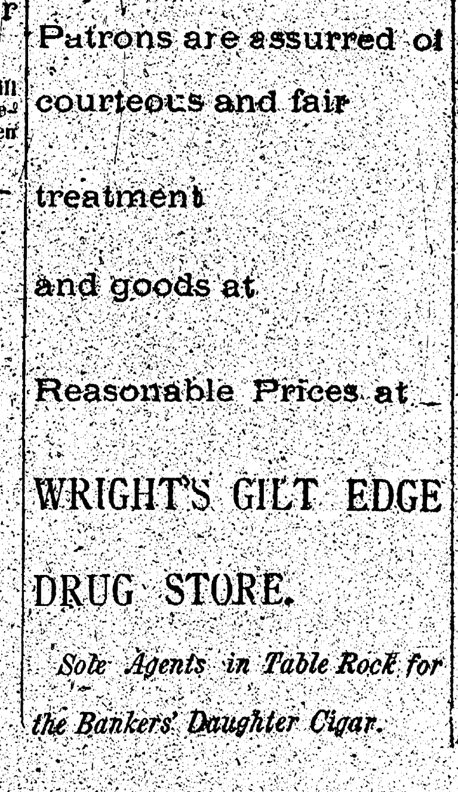

2/10/1893:
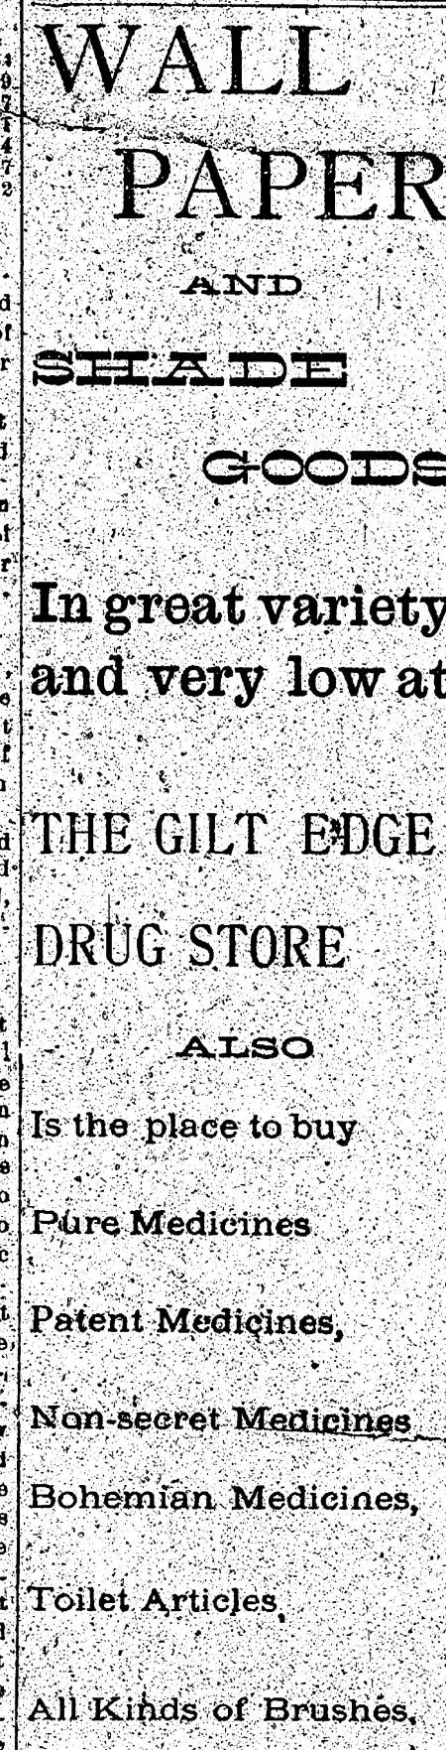
Sherry Winkinhofer commented: Dragons blood is actually a type of herbal supplement - from wikipedia - "Dragon's blood is a bright red resin that is obtained from different species of a number of distinct plant genera: Croton, Dracaena, Daemonorops, Calamus rotang and Pterocarpus. The red resin has been in continuous use since ancient times as varnish, medicine, incense, and dye. "
Carolyn Sue Uhri-Rottman commented, “My grandkids love Dragon’s Blood Slushies,”

Photo 205: This is a small flag that is tagged as being of an unknown source; it was found at the library. There is writing on it, which says: “Waved in greeting [William Jennings] Bryan at Table Rock October 17, 1908, where he spoke to a very enthusiastic crowd, Ada Justice.”

Photo 211. Klub Komensky Czech club, Chapter 8. Back row: Caroline Strejc Marshall, Ida Foale Vrtiska, Vincie Foale Kalina, Emma Vondrasek Goodenkauf, Minnie Strejc Dolby, Helen Petrasek Tomek, Josie Kovanda Kune, Mary Tomek Vondrasek, Mary E Petrasek Kovanda, Mary M Petrasek Wopata, Julia Strejc Brewer. FRONT ROW: Rudolph Vrtiska, Otto Vondrasek, Joseph Wopata, Joe C Tomek, Chas Rabstejnek, Jess Vondrasek, Joe Tomek, Fred Blaker, Arnold Petrasek, Emil Rabstejnek, Joe Karas, Ed Wopata, John Tomek, Phil Rabstejnek, Rudolph Wopata

Photo 212, Class of 1908 by Archer King.
Comments by Edward Tomek, 1/14/2015 about Photo 212, which included picture Julia and Minnie Strejc.
The Minnie Strejc in this picture lived in Seattle. Her married name was Dalby. When my wife and I went to the World's Fair in Seattle in 1964?, we stayed with she and her husband, Oscar. They had invited anyone from Table Rock coming to the fair was welcome to stay with them, so we did. The other Strejc girl, Julia, in the picture, also lived in Seattle. And I think there was a third Strejc girl also lived out there. All were graduates of TRHS. One of them, not sure which, never married and was a school teacher. I'm sure I am correct in this information, but will check alumni records when I get home, to make sure.

Photo 226 shows a cast on stage at the Table Rock Theater. It appears to be the cast of a 1952 Play called “An All Star Wedding.” The program for that play is Photo 56. The cast members: Willard Hanna, Marvin Kalina, Lawrence Stehlik, Howard Workman, Alfred Penkava, Elmer Gilbert, Bill Vondrasek, Nettie Stehlik, Art Meier, Orville McKnight, Delmar McClarnen, Albert Rexroth, Lawrence Wenzbauer, Leo Lang, Richard Karas, Allen Gold, M.C. Bonham, Ed Tomek, Edwin Fritch, Roald Workman, Frank Sochor, Edward Tomek, Wayne Minchow, Eddie Kent, Dale Johnson, Edgar Gilbert, Edmund Steiner, George Gilbert, Howard Howell, Lloyd Wright, Dale Right, Rudy Senft, Steve Stasny, Robert Laun, Roy Briant, Louis Sochor, Elmer Penkava, Lyle Hunzeker, Robert Vondrasek, Wayne Diehm, Vernon Reed, and Harvey M. Snider.

Photo 260, District 34 country school undated. Back row: Helen Raitora, Bessie Dobrovolny Luksik, Mathilda Raitora, teacher Mary Petrasek Wopata, and Olga Rabstejnek Sochor. Middle row: Blanche Dobrovolny, Anna Blaha, Julia Blaha, Albina Sedlak Fidermutz, Emma Dobrovolny, Charles Dobrovolny, Albert Krofta, and Ed Dobrovolny. Front row: standing is Emil Sedlak. Seated: Henry Krofta, Frank Krofta, and Bill Sedlak.
Boy on the left, standing on step is Emil Sedlak, 1908-1965, http://www.findagrave.com/cgi-bin/fg.cgi?page=gr&GRid=32412739. Sitting, front row, Henry Krofta, 1899 – 1969, http://www.findagrave.com/cgi-bin/fg.cgi?page=gr&GSln=krofta&GSfn=henry+&GSbyrel=all&GSdyrel=all&GSst=31&GScntry=4&GSob=n&GRid=55003941&df=all&. Frank Krofta, 1901 – 1973, http://www.findagrave.com/cgi-bin/fg.cgi?page=gr&GSln=krofta&GSfn=frank&GSbyrel=all&GSdyrel=all&GSst=31&GScntry=4&GSob=n&GRid=55003940&df=all&. Bill Sedlak (can’t find on Findagrave). Middle row: the three boys to the far right: Charles Sedlak, Findagrave as Charlie Sedlak, 1901 – 1943, http://www.findagrave.com/cgi-bin/fg.cgi?page=gr&GSln=dobrovolny&GSpartial=1&GSbyrel=all&GSdyrel=all&GSst=31&GScntry=4&GSob=n&GRid=32414172&df=all&. Charles Dobrovolny. Albert Krofta, 1898 – 1941, http://www.findagrave.com/cgi-bin/fg.cgi?page=gr&GRid=46255512. Ed Dobrovolny, 1898 – 1980, http://www.findagrave.com/cgi-bin/fg.cgi?page=gr&GRid=137772459. Albina Sedlak Fidermutz, 1899 – 1979, http://www.findagrave.com/cgi-bin/fg.cgi?page=gr&GSln=fidermutz&GSfn=albina&GSpartial=1&GSbyrel=all&GSdyrel=all&GSob=n&GRid=66443867&df=all&. Bessie Luksik, 1896 – 1975, http://www.findagrave.com/cgi-bin/fg.cgi?page=gr&GRid=32415213

Photo 260 of the Table Rock Historical Society, an undated photo of students at District 34 country school.

Photo 261, Bush School, District No. 40. 17 names are given, but there are 18 peope in the picture! I’ve labeled them in a way that I THINK is correct. It leaves a girl in the front row as unknown. It takes into account order (girl boy, etc). Back row is ____ Metz, Eva Strater, Anna Deubelbeiss (teacher), George Swallam, Emile Pohlman, Mae Skillet, Marbaret Deubelbeiss, Emma Skillet Wren. Photo 261d, School Dist 40, Front row Vera Buchales Metz, Elma Burrow, Dennis Skillet, Hazel Skillet Huert, Carl Burow, John Deubelbeiss, _____ Metz, Ernest Gutzmer, Louise Antholz

Photo 262. District 33. This is a classroom with handwritten notes about the student’s names. Unfortumately, there were 3 notes and their order was maintained so we don’t know which students go with which name. When posted on Facebook, Terry Purcell said that Emory Purcell, who is on the list,w as actually Emory Miller, who her great grandpa adopted from the Orphan Train. Terry says the family story is that Emory Miller was so much trouble that they sent him back to New York.

Photograph 287, Volley ball team. Jackie Uhri, 10/13/14: “It was 1964! We won the 32-team volleyball tournament at Peru State College!!!”
Back row:
1. Wava Roberts
2. Pat Diehm
3. Barb Workman
4. Nancy Jasa
5. Marcia Binder
6. Becky Hunzeker
Front row:
1. Pattie Mertes Stevens
2. ________ Jasa?
3. Karen Wenzbauer Gilbert
4. Evelyn Rue Sharp
5. Jackie Flider Uhri
6. Janet Flider

Photos 289 & 290, two views of same unidentified house. MAYBE IDENTIFIED: Kari Cumro Kanel messaged me in March 2015: “I was looking through the pictures of houses in and around Table Rock. I'm not 100% sure but think your pictures 289 and 290 may have been south of town on some ground Kenny Gilbert owned. I see the brick factory smoke stack in the back ground. This house would have been on the hill east of where Bob Vondrasek lived. The house was moved to where my dad Kenny Cumro lives and was changed into a garage. Again I'm not 100% sure but it sure does look like it! Thanks for sharing these pictures as I love old houses and the architecture of each house!”

Photo 291: The back of this picture states that it was taken at some time prior to 1900, it is a play in Pawnee City, the name of the play was Isle of Tasborne, and it was loaned by Louie Blecha.

Photo 292, two school pictures
Two photos of classes at the TR school are mounted on the same board. The one on the left, which appears to be of high school students, has a tag affixed; the one on the right bears no identifying information.
Photos 292a and b show the pictures on the board together, Photo 291c is the photo on the left, Photo 292d is the photo on the right
Photo 292c - The photograph on the left:
This picture has a tag that simply lists 14 names; there are 15 people in the picture:
“Willis Bethel, Durward Hayek, Frank Briant, Ed Blecha, Marvin Shephard, Lavon Jones, Alena Norris, Helen Bain, Mary Wood, Hobart Phillips, _________ McKnight, Cleo Aylor, Alene Shellenberger, ______McKnight”
Photos 293 - 296 photos 293 to 296 in same envelope, labeled with same handwriting
Photo 293, Minnie Boggs
Photo 294, Mr. & Mrs. George Lane family
Photo 295, Mertie Avery, photo by Hughes Studio in Humboldt, NE
Photo 296, Jimmy Dovakas
Photo 297, Horses to side of Presbyterian Church, very faded
Photo 298 & 299 are cast pictures for a Table Rock High School Class play in 1913. the pictures are identical EXCEPT that the board showing the name of the play is different. In one it is Engaged by Wednesday, in the otherit is Married by Wednesday. Error? Two related plays?
Photo 300 – This photo is in a frame imprinted with holly leaves and “Season’s Greetings” and on the front bears the inscription: “Isa. XXVI – 3, St. John XVI – 83, Table Rock M.E. Church – 1903 –“ On the back, the bible verses are quoted.

